**Project Design Phase-I**

**Solution Architecture**

|  |  |
| --- | --- |
| Date | 19 September 2022 |
| Team ID | PNT2022TMID34081 |
| Project Name | Deep Learning Fundus Image Analysis for Early Detection of Diabetic Retinopathy |
| Maximum Marks | 4 Marks |

**Solution Architecture:**

The automated screening of patients at risk of developing diabetic retinopathy represents an opportunity to improve their midterm outcome and lower the public expenditure associated with direct and indirect costs of common sight-threatening complications of diabetes. This study aimed to develop and evaluate the performance of an automated deep learning–based system to classify retinal fundus images as referable and non referable diabetic retinopathy cases, from international and Mexican patients.

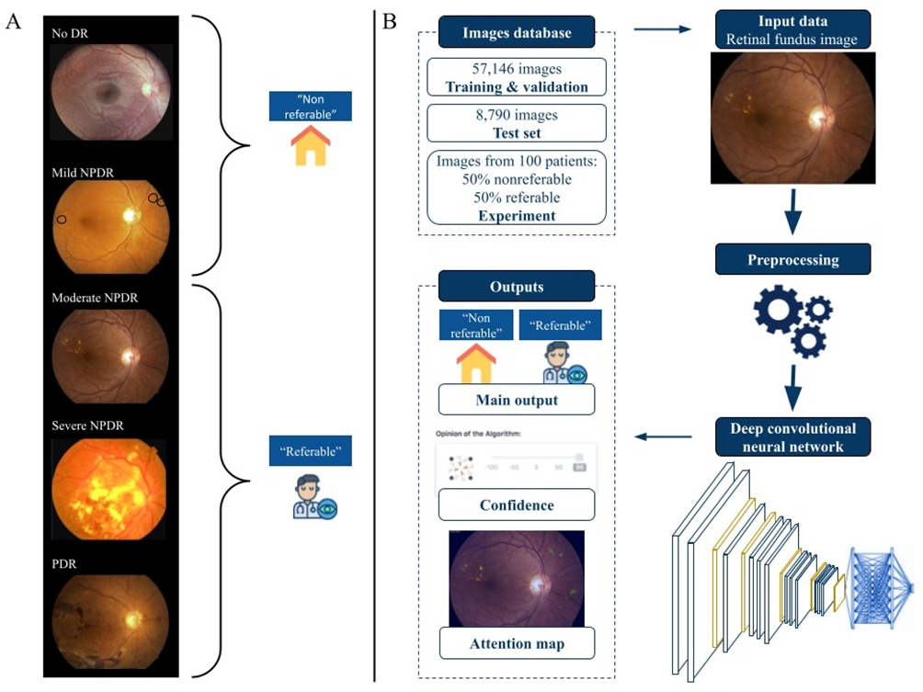

Deep learning–based automated retinal image analysis system. (A) Example of classified retinal fundus images according to the International Clinical Diabetic Retinopathy Severity Scale used for the training data. (B) Flow chart describing the design of the automated retinal image analysis system; the data used for training, validation, and testing; and the algorithm’s outputs. DR: diabetic retinopathy; NPDR: non proliferative diabetic retinopathy; PDR: proliferative diabetic retinopathy

Before classifying the images and training the algorithms, a pre processing procedure was applied. The procedure consisted of cropping the background to eliminate non informative areas, padding the image to guarantee consistent squared image ratios, resizing the image to 224×224 pixels, and normalizing pixel values to the range 0-1.